Sean Clay
Math/CS 375
11/25/2025
Computer Assignment 2
Write-Up
- I ultimately decided on using some of the “simpler” methods, Jacobian and Gaussian, although in hindsight Conjugate-Gradient Method might have been easier to implement, surprisingly. I had difficulty figuring out a good way to implement Gaussian. I wanted to set a good baseline for the iterations by starting with the Jacobian, and I thought using the Gaussian would be a fun challenge. The fact that the Gauss-Seidel iterations solved the matrix using so few iterations is also interesting to point out, though. I would’ve liked to see it in comparison to CGM.
Iterations | Jacobian | Gauss-Seidel
0 | 108.983299 | 107.536040
1 | 9.441744 | 9.899495
2 | 1.124362 | 2.000000
3 | 0.148984 | 0.000000
4 | 0.020960
5 | 0.003063
6 | 0.000459
- Error Results: (Tests were done with the same random matrix)
- Pictures on the next page, it is interesting that the 2nd CSV file is more “hazy” and eventually comes through to look more like CSV 1, I’m assuming that’s intended. The CSV 1 file looks less grainy, like there’s more “continuity” in the same color areas once the filter is applied. It almost looks like the white top of the mug is brighter than it would be normally without the filter.
- 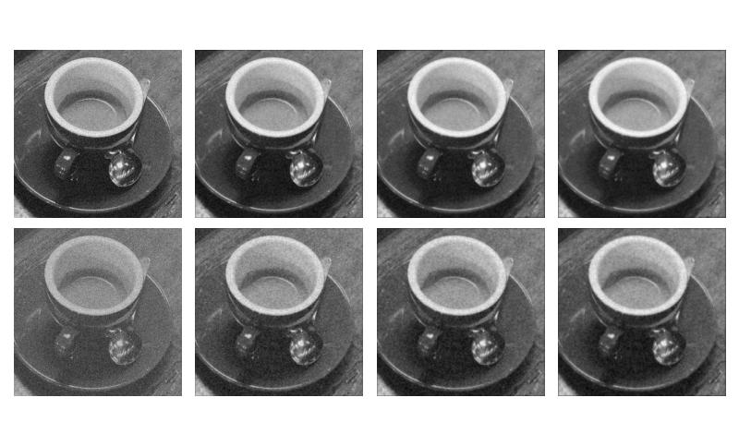
Jacobian Iterated Images – From left to right: original, then lamba = .5, 1.0, 1.5, respectively
- 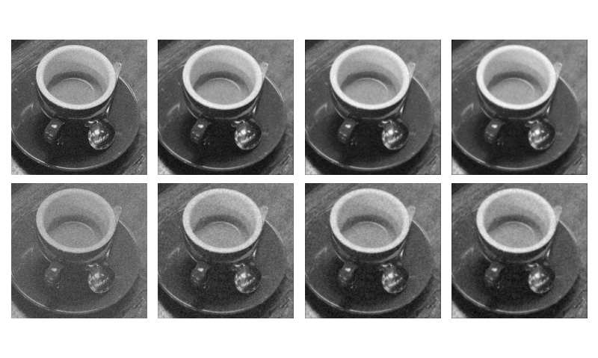
Gauss-Seidel Iterated Images – From left to right: original, then lamba = .5, 1.0, 1.5, respectively

